Sunday and Tuesday Lunch Events
If you are living with or affected by HIV join us for our legendary lunches in a friendly and warm environment with friends, and enjoy some home cooked food. Lunch is free, just bring along something to drink if you wish.
Lunches are held at our centre in Russell Avenue St Albans. They are always very popular so please do let us know if you would like to attend. All are welcome, bring a friend or two if you like, just please let us know so we can cater for numbers!
If you cannot make the Sunday events remember we have a lunch every Tuesday from 12.30 too, again all are welcome!

PLEASE ARRIVE BY 2 PM TO ENSURE YOU GET A FRESH LUNCH SERVED
SUNDAY LUNCH DATES FOR 2017
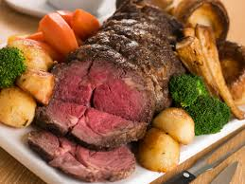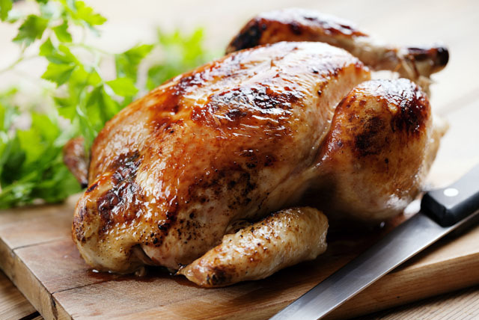
25 JUNE 30 JULY 27 AUGUST 24 SEPTEMBER

29 OCTOBER 26 NOVEMBER 29 DECEMBER (Christmas Lunch)

TUESDAY LUNCHES
1:00pm onwards every Tuesday, (drop in opens from 10am)

